PURPOSE
What is Screening? Screening is the process of eliminating subjects from consideration. This simulation screener is used to identify men and influencers suitable for participating in intervention simulations by determining their intensity score for a specific barrier the intervention being tested intends to resolve. Higher scores equal higher intensity. It is only appropriate to include individuals who score high on the intensity scale.

HOW TO USE
The testing screener is comprised of 6 sections that align to the barrier themes:
- Lack of benefit relevance
- Anticipated pain
- Anticipated loss
- Distrust
- Uncertainty
- Anticipated shame

Within each section you will find an image, story narrative(s), and 10-point scale questions used to score intensity.

First, find the 10-point scale question that aligns to the specific barrier your intervention intends to resolve. Above that question, identify the story narrative that aligns to it. Above the story narrative, identify the picture that aligns to it.

Now, copy and paste this question in another document to identify what stage the man is in:

How would you best describe your VMMC status out of these options?
  - You do not believe in the benefits
  - You believe in the benefits but are not committed
  - You are committed but have not scheduled the procedure
  - You have scheduled but have not been circumcised
  - You have been circumcised but are not advocating

Then, copy and paste the story narrative and 10-point scale question on page 1 in that document. Finally, copy and paste the picture on page 2 of that document. Now print the document. Make sure the image is on a separate page from the story narrative and 10-point question. These are the pages that the person doing the screening will use in the field in alignment with the INSTRUCTIONS. An example combination for improved perception by women is show below:
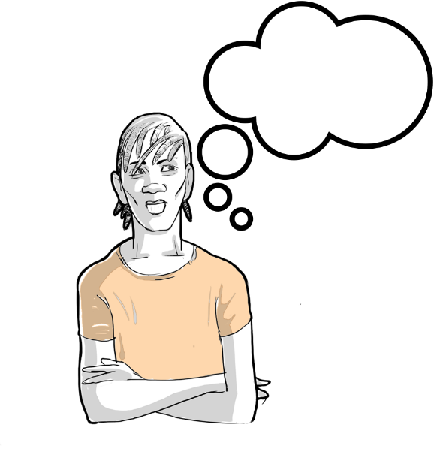
- How would you best describe your VMMC status out of these options?
  - You do not believe in the benefits
  - You believe in the benefits but are not committed
  - You are committed but have not scheduled the procedure
  - You have scheduled but have not been circumcised
  - You have been circumcised but are not advocating

A man like you is contemplating VMMC. He’s heard about some of the benefits and is wondering if they will apply to him. Imagine that you are there to give him advice…

On a scale of 1-10, how doubtful should he be that VMMC will improve how women perceive him?

LACK OF BENEFIT RELEVANCE
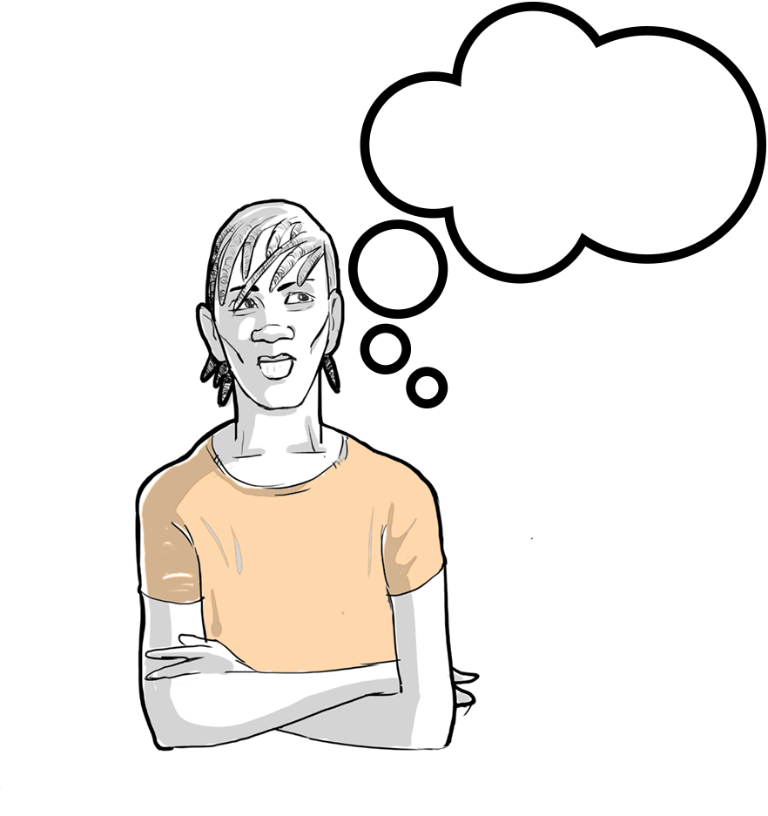
A man like you is contemplating VMMC. He’s heard about some of the benefits and is wondering if they will apply to him. Imagine that you are there to give him advice…

PROTECTION FROM HIV
On a scale of 1-10, how doubtful should he be that VMMC will protect him from HIV?

PROTECTS PARTNER FROM HPV/STIs
On a scale of 1-10, how doubtful should he be that VMMC will protect his partner from HPV / STIs?

NO RISK IN MONOGAMY
If this man is in a monogamous relationship, on a scale of 1-10, how confident should he be that monogamy will be enough to keep him safe from HIV / STIs?

IMPROVED PERCEPTION BY WOMEN
On a scale of 1-10, how doubtful should he be that VMMC will improve how women perceive him?

SEX LASTS LONGER
On a scale of 1-10, how doubtful should he be that VMMC will make sex last longer for him?

IMPROVED HYGEINE
On a scale of 1-10, how doubtful should he be that VMMC will improve his hygiene?

PROTECTION FROM STIs
On a scale of 1-10, how doubtful should he be that VMMC will protect him from STIs?

PROTECTS THE COMMUNITY
On a scale of 1-10, how doubtful should he be that VMMC will help protect his community?

ANTICIPATED PAIN
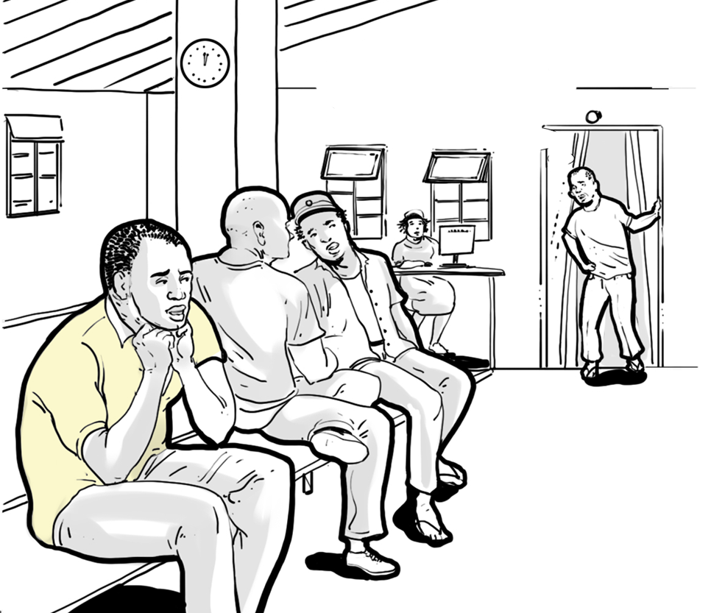
Imagine that the man in this story is deciding whether or not to go for VMMC. He has heard a lot of the same things you have about the pain involved and is trying to work up the courage to do the procedure.

PAIN OF PROCEDURE
On a scale of 1-10, how concerned do you think he should be about pain during the procedure?

PAIN OF HEALING
On a scale of 1-10, how concerned should he be about the pain of healing?

ANTICIPATED LOSS
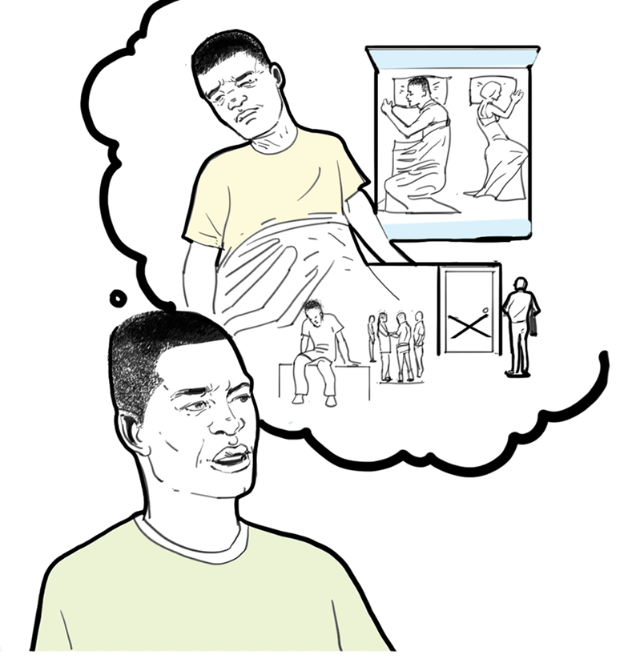
Imagine that the man in this story has a lot of the same responsibilities that you do. He's thinking about how to make time in his life for the procedure, but also about the importance of work and his wages.

LOSS OF WAGES
On a scale of 1-10, how concerned should he be about missing work / wages because of VMMC?

Imagine that the man in this story is part of a community much like yours. He's unsure of how people in his religious community will feel about him after the procedure, and whether he will still feel like part of that community.

LOSS OF RELIGIOUS ALIGNMENT
On a scale of 1-10, how concerned should he be about not being able to fit in with his religious community after VMMC?

The man in this story knows that once he has the procedure, he won't be able to have sex for [6 weeks]. He's thinking about how long that is, and he's worried about being able to avoid the temptation.

LOSS OF SEX
On a scale of 1-10, how concerned should he be about not being able to have sex after VMMC?

Imagine that the man in this story has heard a lot of the same things you've heard about how sex will feel after the procedure.

LOSS OF PLEASURE
On a scale of 1-10, how concerned should he be about losing sensitivity and pleasure after VMMC?

DISTRUST
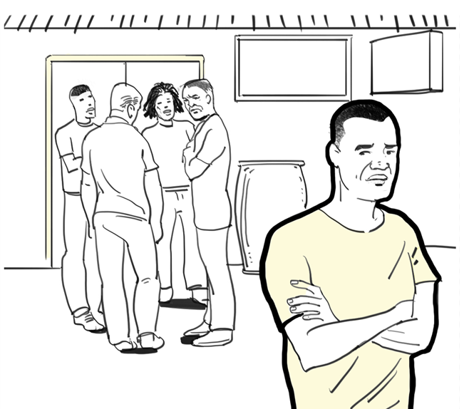
Imagine that, just like you, the man in this story has heard descriptions of how painful the procedure and healing is.

DISTRUST OF MEN UNDER-REPRESENTING PAIN
On a scale of 1-10, how concerned should he be that what he's heard is inaccurate?

Imagine that the man in this story has been dating his current partner for a while, and recently she brought up VMMC. She's suggested that he look into the procedure. Try to imagine how he feels when he hears this.

DISTRUST OF WOMEN’S INTENT MAKING PARTER REQUEST
On a scale of 1-10, how suspicious should he be of her motives?

Imagine that the man in this story has been dating his current partner for a while, and recently he’s been thinking about discussing VMMC with her.

PARTNER DISTRUSTING MAN IN MONOGAMY
How concerned should he be that his partner will question his loyalty to her?

UNCERTAINTY
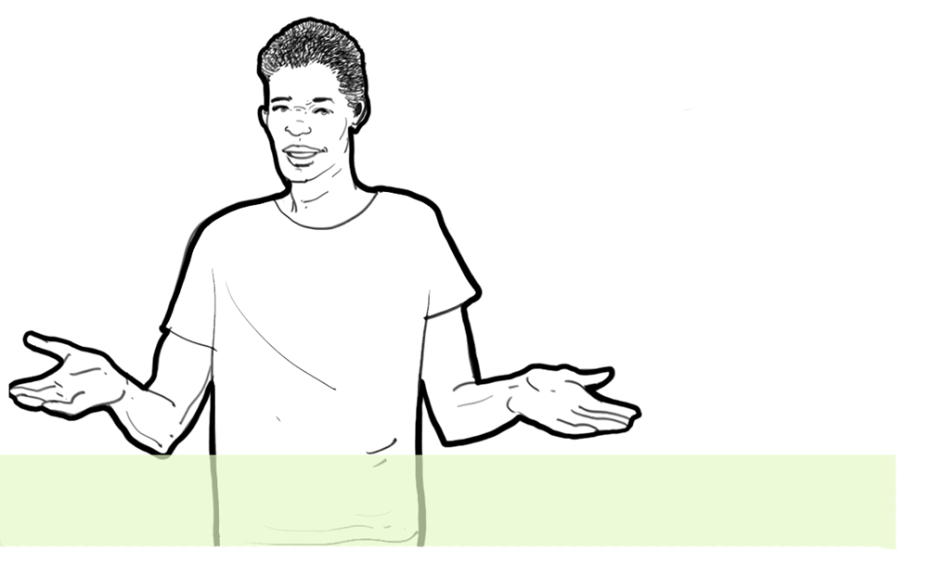
Imagine the man in this story is just like you and he’s contemplating whether to go for VMMC or not.

UNCERTAINTY OF SURGICAL COMPLICATIONS
On a scale of 1-10, how concerned should he be about hidden risks he may not know about?

UNCERTAINTY OF PROCEDURE STEPS AND TIMELINES
On a scale of 1-10, how concerned should he be about learning the procedure steps and timelines before going?

UNCERTAINTY OF PROCEDURE IMPLICATIONS
On a scale of 1-10, how concerned should he be about how sex will feel after VMMC?

ANTICIPATED SHAME
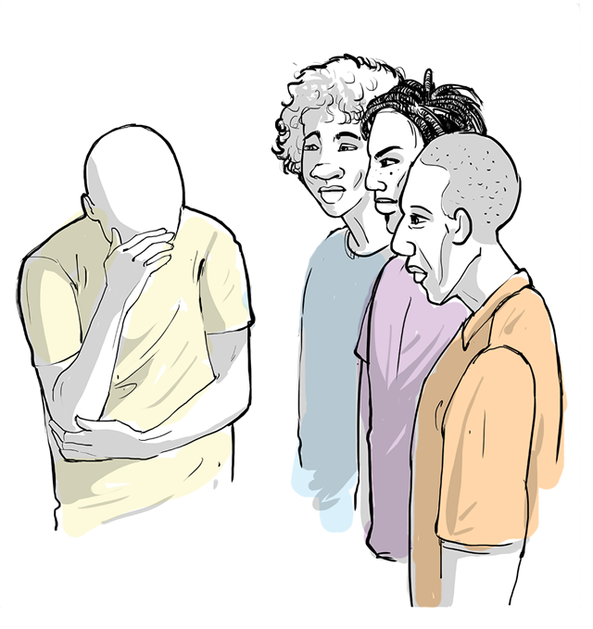
The man in this story isn't quite sure what to expect when he gets to the clinic, but he has heard that he might be waiting for the procedure with other men who may be older or younger than him, and that female nurses may be interacting with him. He's not sure how he feels about this.

SHAME AT TIME OF SERVICE
On a scale of 1-10, how concerned do you think he should be about that?

The man in this story is trying to imagine himself after the procedure, getting home afterwards and how he will spend his recovery time. He's not sure how he will feel after, and if people will notice something different about him.

SHAME WHILE HEALING
On a scale of 1-10, how concerned do you think he should be about looking or behaving differently in front of others while healing?

The man in this story lives in a village/town similar to yours. He's thinking about how he will feel telling other people that he's had VMMC. Think of the different people he may end up talking to about it.

SHAME WHEN TELLING OTHERS
On a scale of 1-10, how concerned do you think he should be about people's reactions when he tells them he's been circumcised?

